AIM: To implement and simulate spatial domain image filtering techniques in Python, including image smoothing using linear (Gaussian, Box/Averaging) and non-linear (Median) low-pass filters to reduce noise, as well as image sharpening using spatial high-pass (Laplacian and derivative) kernels to enhance fine details and edge transitions.
PROGRAM:
Cell 1:
import cv2
import numpy as np
from google.colab.patches import cv2_imshow

image = cv2.imread("defender.jpg")

if image is None:
print("Error: Image not found. Check the path!")
exit()

kernel_size = (5, 5)
sigma = 1.5
gaussian_kernel = cv2.getGaussianKernel(kernel_size[0], sigma)
gaussian_kernel = np.outer(gaussian_kernel, gaussian_kernel)
smoothed_image = cv2.filter2D(image, -1, gaussian_kernel)

sharpening_kernel = np.array([
[-1, -1, -1],
[-1, 9, -1],
[-1, -1, -1]
])
sharpened_image = cv2.filter2D(image, -1, sharpening_kernel)

cv2_imshow(image)
cv2_imshow(smoothed_image)
cv2_imshow(sharpened_image)

Cell 2:
import cv2
import numpy as np
from google.colab.patches import cv2_imshow

image_path = "/content/defender.jpg"
image = cv2.imread(image_path)

if image is None:
print("Error: Image not found. Check the path!")
exit()

kernel_size = (5, 5)
kernel = np.ones(kernel_size, dtype=np.float32) / (kernel_size[0] * kernel_size[1])

smoothed_image = cv2.filter2D(image, -1, kernel)

cv2_imshow(image)
cv2_imshow(smoothed_image)

Cell 3:
import cv2
from google.colab.patches import cv2_imshow

image_path = "/content/defender.jpg"
image = cv2.imread(image_path)

if image is None:
print("Error: Image not found. Check the path!")
exit()

kernel_size = 5

smoothed_image = cv2.medianBlur(image, kernel_size)

cv2_imshow(image)
cv2_imshow(smoothed_image)

Cell 4:
import cv2
import numpy as np
from google.colab.patches import cv2_imshow

image_path = "/content/defender.jpg"
image = cv2.imread(image_path)

if image is None:
print("Error: Image not found. Check the path!")
exit()

blurred_image = cv2.GaussianBlur(image, (5, 5), 0)

laplacian_kernel = np.array([
[ 0, -1, 0],
[-1, 5, -1],
[ 0, -1, 0]
], dtype=np.float32)

sharpened_image = cv2.filter2D(blurred_image, -1, laplacian_kernel)

cv2_imshow(image)
cv2_imshow(blurred_image)
cv2_imshow(sharpened_image)

OUTPUTS:
Cell 1 output:
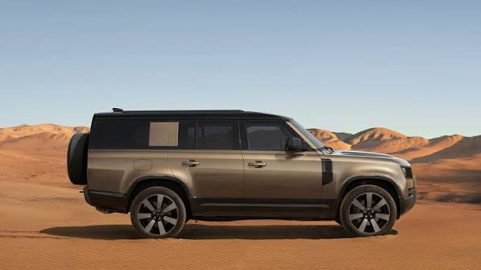
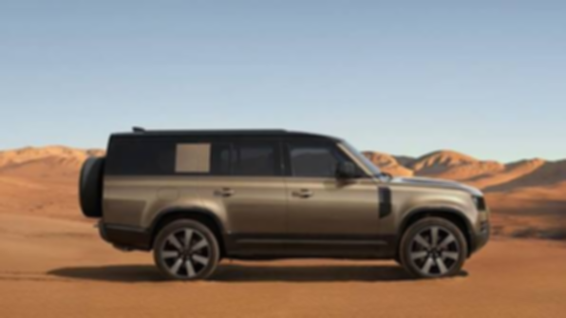
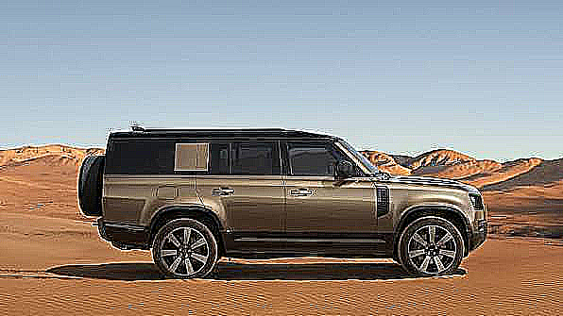

Cell 2 output:

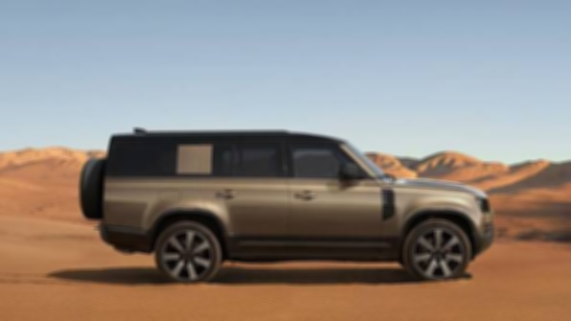

Cell 3 output:

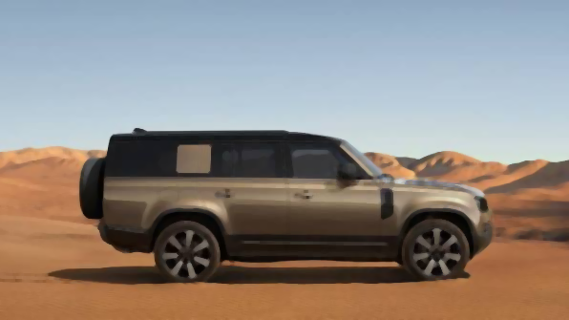

Cell 4 output:

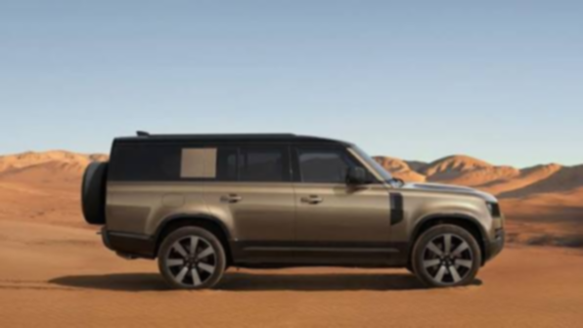
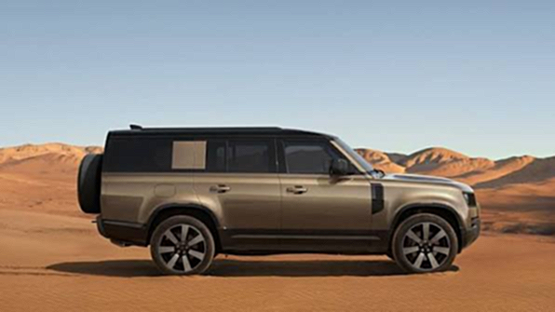

CONCLUSION:
Spatial filtering techniques for image smoothing and sharpening were successfully implemented and evaluated. Linear smoothing using averaging and Gaussian kernels along with non-linear median filtering effectively suppressed high-frequency noise and smoothed intensity transitions across the image. High-pass spatial filtering utilizing the Laplacian kernel successfully amplified high-frequency spatial gradients, significantly enhancing fine edge boundaries and prominent vehicle contours.

